Azat Demir

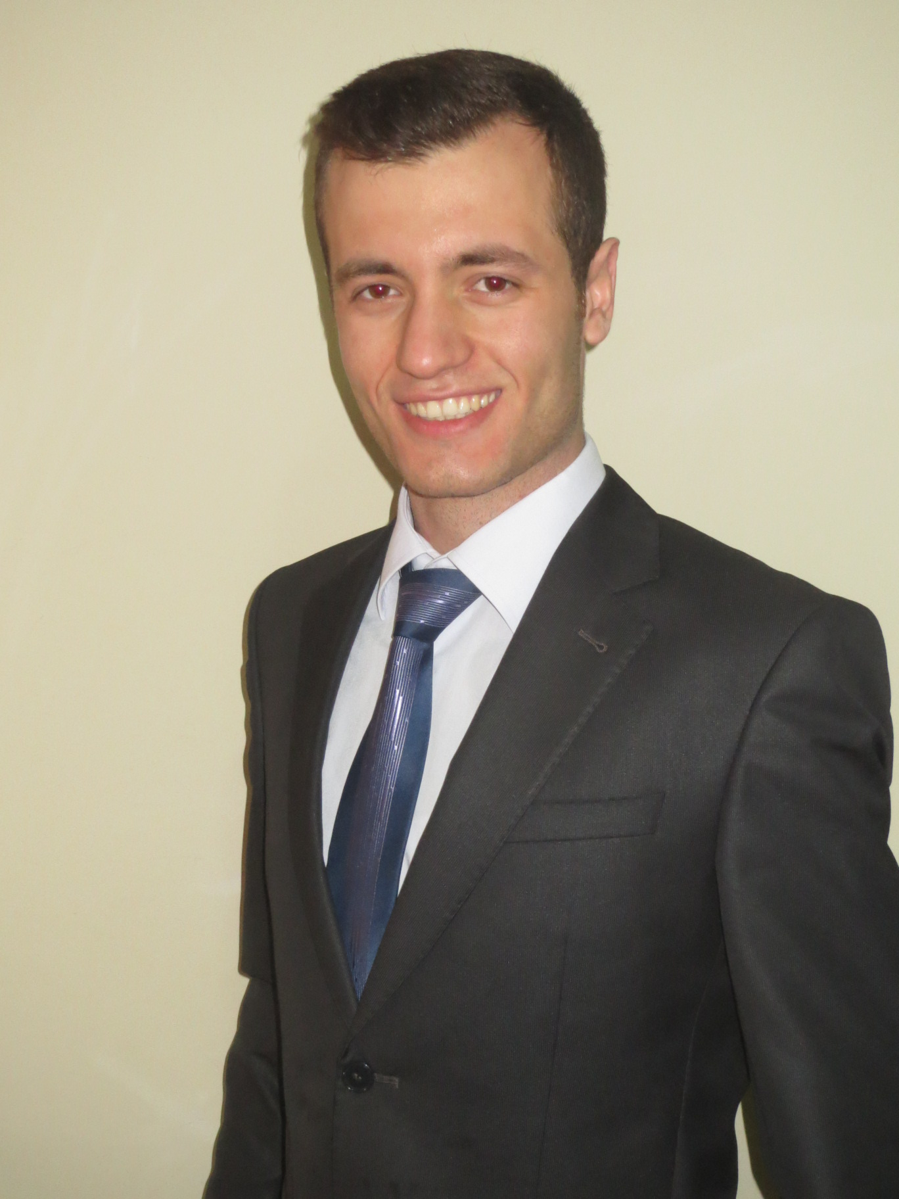toğraf

Turkey - İstanbul(Ana.) - Ümraniye

+90 (530) 732 9768

E-mail : [azatdemir40@gmail.com](mailto:azatdemir40@gmail.com)

Personel Information

Date of Birth : 05.10.1992

Marital Status : Single

Military Status : Done

Job Experience

11.2018-Huawei Software Test Engineer

We have a platform based on web services. It provide us to develop various of API’s, management of these API’s. My responsibilties are prepare and execute tests both manuel and automated technique. Our Works are mostly on Dockerized version of this Platform. So cases contains platform dockerized well or not.

Also I’m responsible for environmental issues. I create, manage and solve environmental problems about virtual machines and servers.

05.2017- Turk Telekom

Software Test Engineer

For the CRM software which Turk Telekom have for the customer, we analyze the development that created by developers, create test scenarios, run them and make regression tests.

According to the project; first we make entegration and demo tests and we start to functional

testing. After functional tests, we make user acceptance tests. Then regression test begin. During this process, we use Waterfall SDLC schema for our projects.

07.2016-12.2016 TekveTek Mobil Araç Takip ve Bilişim Sistemleri A.Ş.

Technical Support Engineer

Our company have the distribution of Baramundi Software which is a German Company. The software is about managing IT operations of companies. It contains clonning, backups, disaster recovery, endpoint management etc. My responsibilty was giving support to customers fort his software. Also, if any problems come out which i can’t handle, i solve problem with engineers in germany via mail or phone.

09.2015-02.2016 Turkcell Grup Şirketleri

Network Engineer

We were solving problems or meeting requests that our corporate customers have.Their problems was mostly about internet connection. According to the type of devices, we were connecting to our customer's network with telnet. If connection is not possiable, we were chasing circuit direction to find it in Superonline's backbone. Our main purposes were understanding problem, even solving the issue if it's possiable at the first step.

07.2014-08.2014 KULVAR

Internship

Company is designing microchips. I have made my projects such as 4 bit counter and some of the logic gates. We have worked with tanner tools and I have learnt this program during internship.

07.2013-08.2013 ÖZ-AK Turnstile A.Ş.

Internship

Designing turnstile circuits and observation of the programming process.

Education Information

09.2010-07.2015 Kocaeli University

Electronic and Communication Engineering 72.2/100

Seminars and Courses

* **Foundation Of Software Testing, Bilge Adam** – 20.01.2018 - 21.01.2018 (10 Hour)

Fundamentals of testing, software development models, (Waterfall, agile etc.) testing techniques were included the course.

* **Bootcamp, Keytorc** - 27.02.2017- 06.03.2017(13 Hour)

SDLC processes, test principles, test levels and types had been taught. Also fundamental information about test engineering have explained during the course.

* **English Course, English Time** - 01.09.2016-10.03.2017(360 Hour)

I have studied in intermediate, upper intermediate and advanced courses.

* **CCNA, Premier Turk** - 01.03.2015-18.05.2015(80 Hour)

In lessons; devices, which Cisco System Firm making, introduced us. Planning a network, fixing problems, which appear in our network system, and making examples about them.

Foreign Language

English : Upper Intermediate

Abilities and Tools

Abilities;

* Service Virtualization
* Service-Oriented Architecture (SOA)
* Test Management
* Software Development Life Cycle
* SQL
* Knowledge about TCP/IP
* Linux
* Bash Scripting Basic Level
* Python Intermediate level
* Knowledge about Docker

Tools;

* Microsoft Office Programs
* JIRA
* SoapUI
* HP Service Virtualization Designer
* HP ALM
* Vmware
* Postman
* Selenium Automation

Personel Properities

* Teamwork skills
* Urgent situation management
* Huge sports fan and willing to see new places